**IFT 266 Introduction to Network Information Communication Technology (ICT)   
  
Lab 24**

**Troubleshoot a VLSM network**

Co-authored by Chris Maness

1. 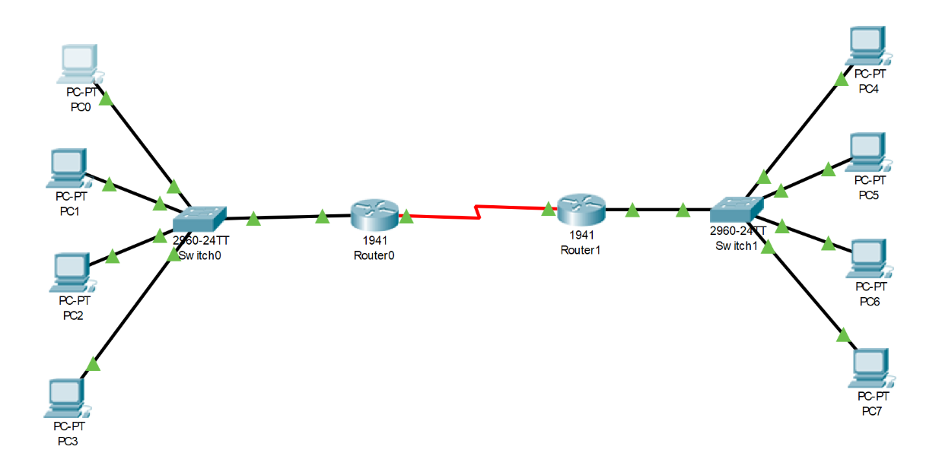Set up the following topology in Packet Tracer.   
     
   You will need to add one HWIC-2T to each router.





1. Configure Router0 with the following commands

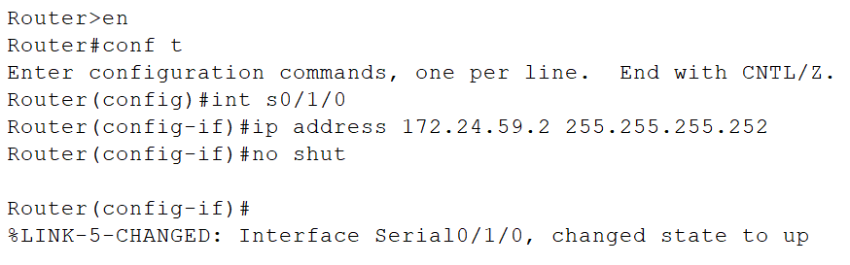

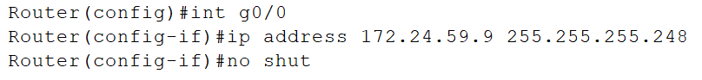



1. Repeat the same for configuration for Router1 but assign s0/1/0 an IP address of 172.24.59.1 and a subnet of 255.255.255.252 and assign g0/0 172.24.59.17 and a subnet of 255.255.255.248.



1. Assign PC0 an IP of 172.24.59.3 and a subnet of 255.255.255.252. What error does Packet Tracer give? and why does it give the error (be specific as to why you get the error and cannot assign this address)?

________________________________________________________________________________________________________________________________________________________________________________________________________________________________________________________________________________________________________________________

1. Create an IP scheme that works for the subnet PC0 is on. The first address is given. The CIDR should be the same for all your addresses.

|  |  |  |
| --- | --- | --- |
| **Device** | **IP Address** | **CIDR (/X)** |
| PC0 | 172.24.59.10 |  |
| PC1 |  |  |
| PC2 |  |  |
| PC3 |  |  |

1. Assign PC4 the IP 172.24.59.16 and a subnet of 255.255.255.248. Why won’t Packet Tracer let you assign this IP (be specific as to why you get the error and cannot assign this address)?

________________________________________________________________________________________________________________________________________________________________________________________________________________________________________________________________________________________________________________________

1. Assign PC4 the IP of 172.24.59.12 and the same subnet (255.255.255.248). Although Packet Tracer lets you assign the IP, this IP would be incorrect.   
     
   List **two reasons** why this IP would not work.

________________________________________________________________________________________________________________________________________________________________________________________________________________________________________________________________________________________________________________________

1. Create an IP scheme like the one you made in Step 5, starting at PC4.

|  |  |
| --- | --- |
| **Device** | **IP Address** |
| PC4 |  |
| PC5 |  |
| PC6 |  |
| PC7 |  |

1. For the scheme you made in the previous step, list the broadcast address, the network address, and the range of usable hosts.

|  |
| --- |
| Broadcast Address - |
| Network Address - |
| Range of Hosts |

1. PC 0 would like to be able to ping PC 4 and vice versa.

With the current network configurations, will this ping be successful? _____________  
  
If not, why not? _______________________________________________________________

**Important**

Please make sure to save your packet tracer file as you will need it for lab 25.